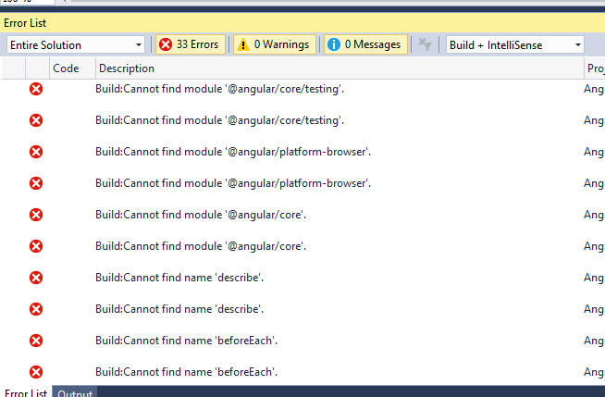

Took some time to get the packages.

Rebuild again

Now we get the error

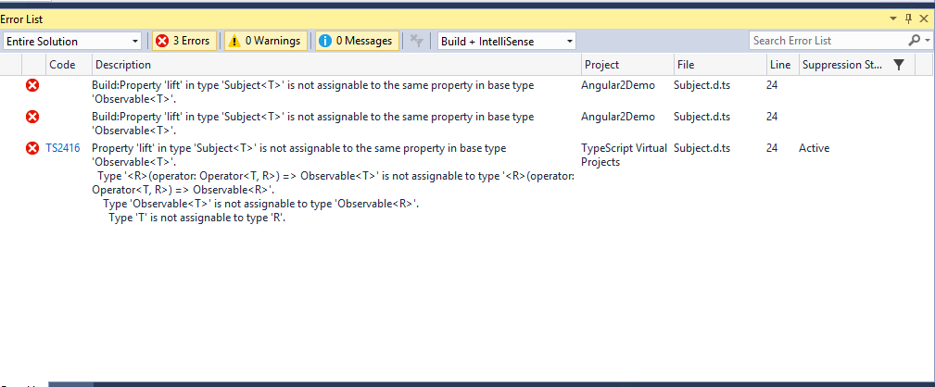

Open Packages.Json

Modify

"rxjs": "5.0.1",

To

"rxjs": "5.4.2",

Delete node-modules folder

Select Package.json. right click Restore Packages

Rebuild

Now the solution builds without any errors

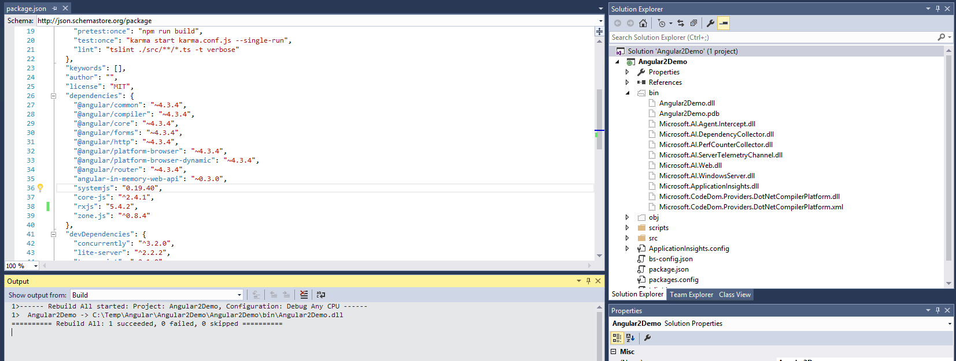

When U run the solution using Ctrl + F5 then u may get the error

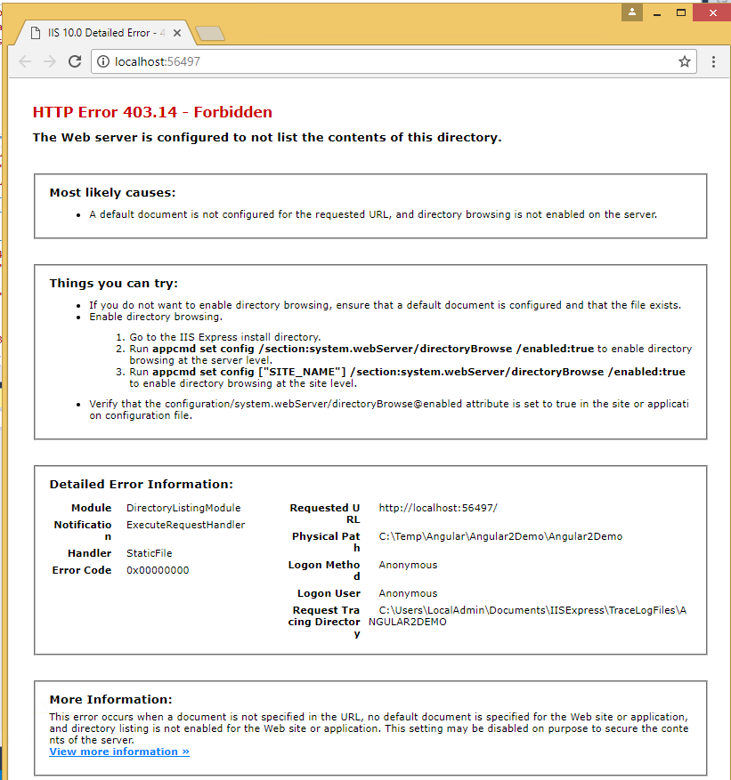

For this make the index.html page as startup page. Then run it